**PERFORMANCE AND ERROR TRACKING DASHBOARD**

Monitoring snowflake Task performance through Snowsight dashboards provides valuable insights into the efficiency and effectiveness of your data transformation processes.Tracking snowflake errors through Snowsight dashboards allows you to identify and resolve issues in your data transformation workflows effectively. This enables you to track trends, compare performance across different time periods or tasks, and identify areas for improvement.

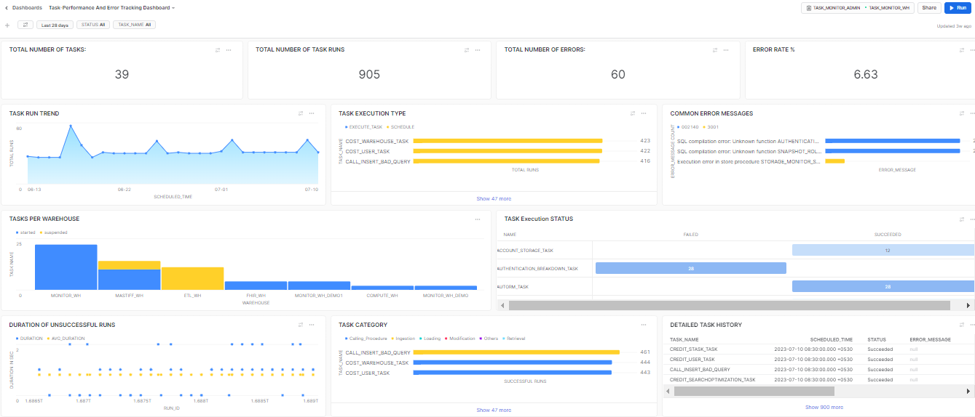

**FILTERS:**

* **DATERANGE(Default Filter)**
* **TASK_NAME(Custom Filter):**

Display Name :- TASK_NAME

SQL Keyword :- TASK_NAME

Role :- ACCOUNTADMIN

Warehouse :- TASK_MONITOR_WH

Options Via :- Query

Write Query :- select distinct name from snowflake.account_usage.task_history;

Go for the below selections :

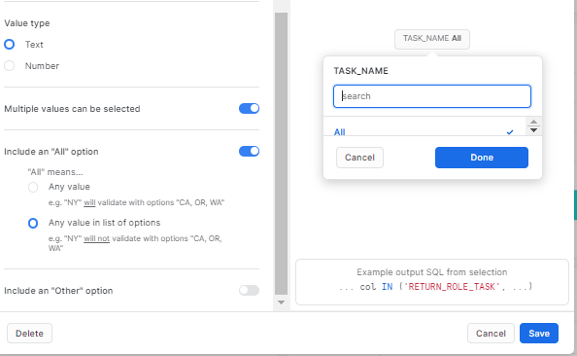

* **STATUS(Custom Filter):**

Display Name :- STATUS

SQL Keyword :- STATUS

Role :- ACCOUNTADMIN

Warehouse :- TASK_MONITOR_WH

Options Via :- List:

SUCCEEDED

FAILED_AND_AUTO_SUSPENDED

FAILED

CANCELLED

SKIPPED

Go for the below selections :

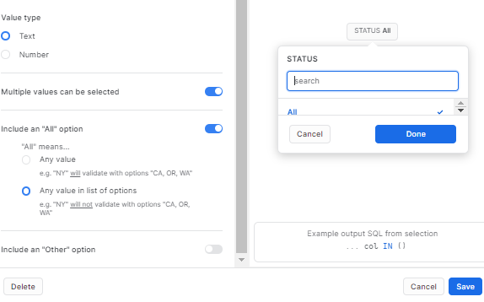

**1.1 TOTAL NUMBER OF TASKS:**

select count (DISTINCT (Name)) from snowflake.account_usage.task_history

WHERE

SCHEDULED_TIME =:daterange;

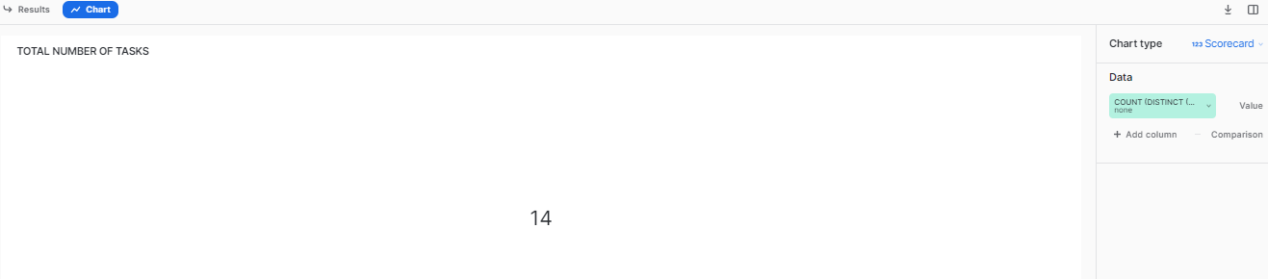

**1.2 TOTAL NUMBER OF TASK RUNS:**

SELECT count(*) FROM SNOWFLAKE.ACCOUNT_USAGE.TASK_HISTORY

WHERE SCHEDULED_TIME =:daterange;

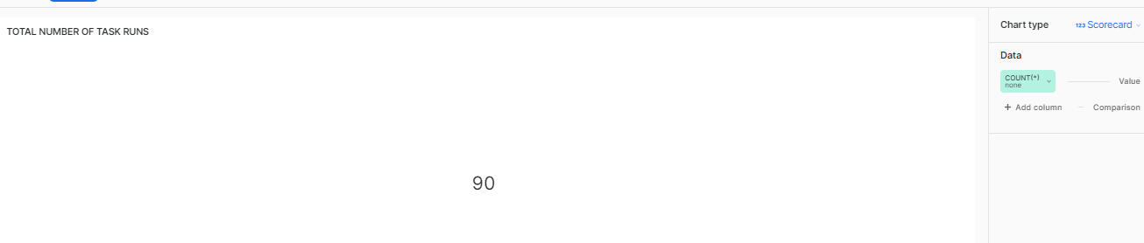

**1.3 TOTAL NUMBER OF ERRORS:**

SELECT count(*) FROM

snowflake.account_usage.task_history

WHERE

INITCAP(STATE) IN ('Failed', 'Cancelled', 'Skipped','Failed_And_Auto_Suspended')

AND SCHEDULED_TIME = :daterange ;

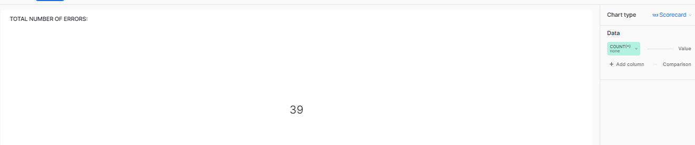

**1.4 ERROR RATE %:**

select round(100*((SELECT count(*) FROM

snowflake.account_usage.task_history

WHERE

INITCAP(STATE) IN ('Failed', 'Cancelled', 'Skipped','Failed_And_Auto_Suspended')

AND SCHEDULED_TIME = :daterange)/(SELECT count(*) FROM SNOWFLAKE.ACCOUNT_USAGE.TASK_HISTORY

WHERE SCHEDULED_TIME =:daterange)),2) AS ERROR_RATE;

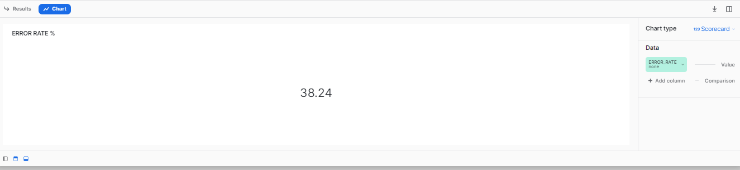

**1.5 TASK RUN TREND:**

SELECT

NAME as TASK_NAME,

date_trunc(

'second',

CONVERT_TIMEZONE('Asia/Calcutta', SCHEDULED_TIME)

) as SCHEDULED_TIME,

TIMESTAMPDIFF(SECOND, QUERY_START_TIME, COMPLETED_TIME) as DURATION,

INITCAP(STATE) as STATUS,

SCHEMA_NAME,

DATABASE_NAME

FROM

snowflake.account_usage.task_history

WHERE

SCHEDULED_TIME =:daterange

AND STATE=:STATUS

AND NAME=:TASK_NAME;

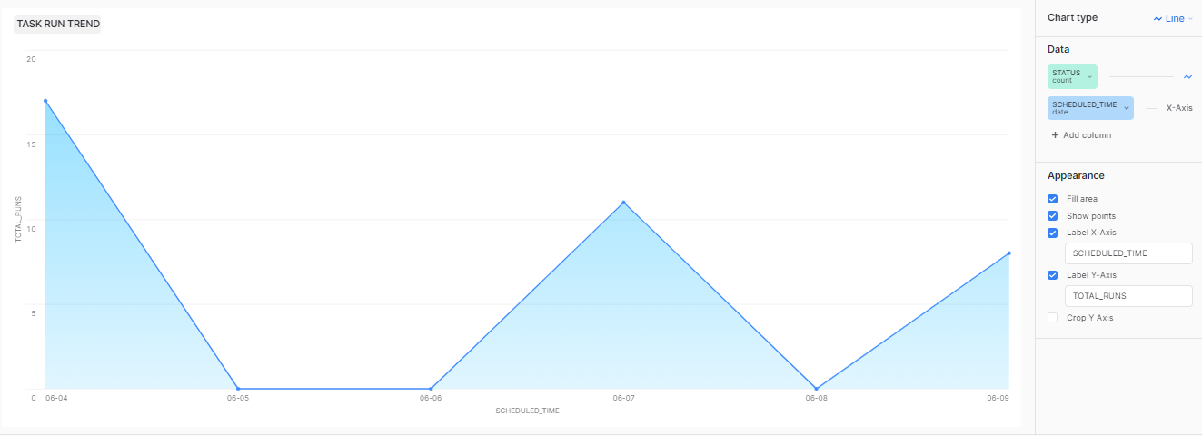

**1.6 TASK EXECUTION TYPE:**

SELECT NAME AS TASK_NAME,SCHEDULED_FROM FROM SNOWFLAKE.ACCOUNT_USAGE.TASK_HISTORY WHERE TASK_NAME=:TASK_NAME;

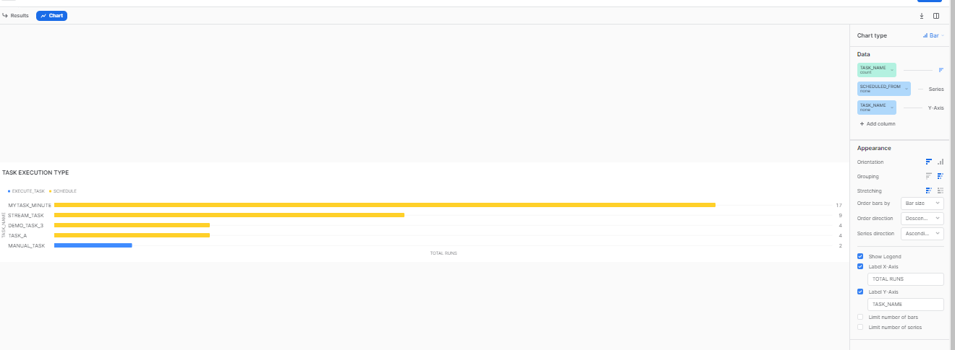

**1.7 COMMON ERROR MESSAGES:**

SELECT

NAME as TASK_NAME,

date_trunc(

'second',

CONVERT_TIMEZONE('Asia/Calcutta', SCHEDULED_TIME)

) as SCHEDULED_TIME,

INITCAP(STATE) as STATUS,

date_trunc(

'second',

CONVERT_TIMEZONE('Asia/Calcutta', QUERY_START_TIME)

) as START_TIME,

date_trunc(

'second',

CONVERT_TIMEZONE('Asia/Calcutta', COMPLETED_TIME)

) as END_TIME,

TIMESTAMPDIFF('millisecond', QUERY_START_TIME, COMPLETED_TIME) as DURATION,

SCHEMA_NAME,

DATABASE_NAME,

ERROR_CODE,

ERROR_MESSAGE,

QUERY_ID

FROM

snowflake.account_usage.task_history

WHERE

INITCAP(STATE) IN ('Failed', 'Cancelled', 'Skipped','Failed_And_Auto_Suspended')

AND SCHEDULED_TIME = :daterange;

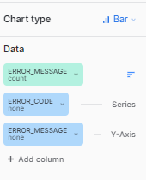

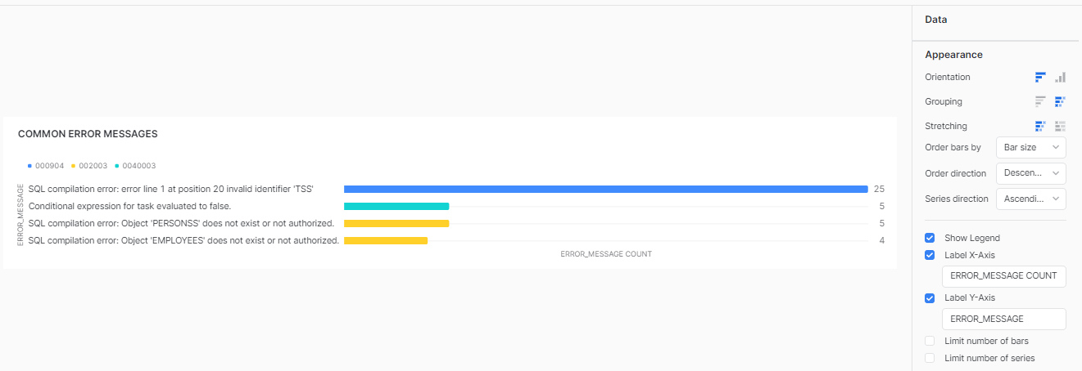

**1.8 TASKS PER WAREHOUSE:**

SHOW TASKS;

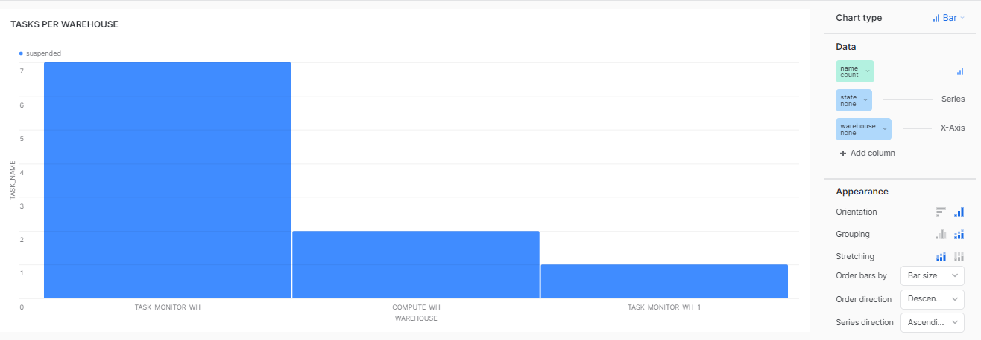

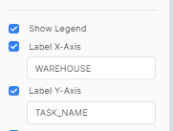

**1.9 TASK Execution STATUS:**

select STATE, NAME,date_trunc('second',

CONVERT_TIMEZONE('Asia/Calcutta', SCHEDULED_TIME)

) as SCHEDULED_TIME,TIMESTAMPDIFF('millisecond', QUERY_START_TIME, COMPLETED_TIME) as DURATION,

ERROR_MESSAGE from snowflake.account_usage.task_history

WHERE SCHEDULED_TIME = :daterange AND NAME = :TASK_NAME;

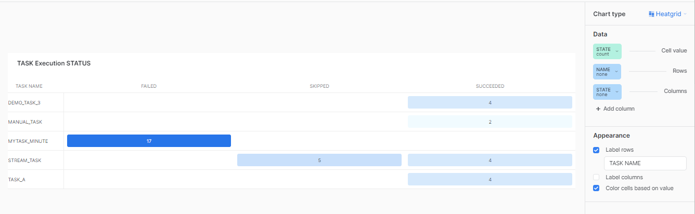

**1.10 DURATION OF UNSUCCESSFUL RUNS:**

SELECT

NAME as TASK_NAME,

date_trunc(

'second',

CONVERT_TIMEZONE('Asia/Calcutta', SCHEDULED_TIME)

) as SCHEDULED_TIME,

INITCAP(STATE) as STATUS,

RUN_ID,

TIMESTAMPDIFF(SECOND, QUERY_START_TIME, COMPLETED_TIME) as DURATION,

(select avg(duration) from (select TIMESTAMPDIFF(SECOND, QUERY_START_TIME, COMPLETED_TIME) as DURATION from snowflake.account_usage.task_history WHERE

SCHEDULED_TIME =:daterange AND NAME=:TASK_NAME AND INITCAP(STATE) IN ('Failed', 'Cancelled','FAILED_AND_AUTOSUSPENDED'))) as avg_duration,

SCHEMA_NAME,

DATABASE_NAME

FROM

snowflake.account_usage.task_history

WHERE

SCHEDULED_TIME =:daterange AND NAME=:TASK_NAME

-- AND STATE=:STATUS

AND INITCAP(STATE) IN ('Failed', 'Cancelled','FAILED_AND_AUTOSUSPENDED')

ORDER BY

DURATION DESC ;

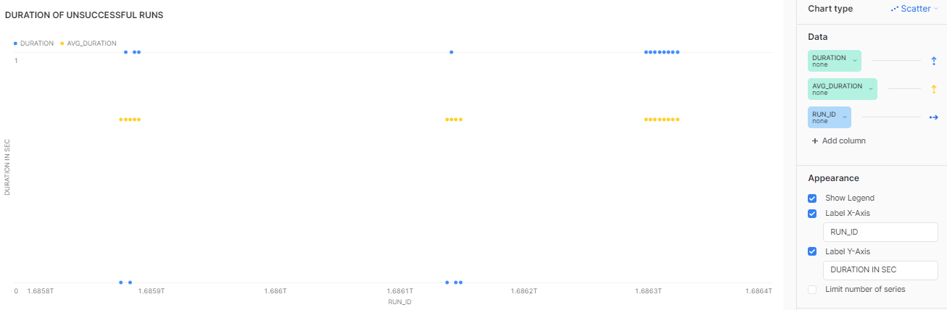

**1.11 TASK CATEGORY:**

SELECT NAME as TASK_NAME ,QUERY_TEXT,STATE AS STATUS,

CASE

WHEN lower(QUERY_TEXT) like '%insert%' AND upper(CONDITION_TEXT) like '%SYSTEM$STREAM_HAS_DATA%' THEN 'CDC'

WHEN lower(QUERY_TEXT) like '%insert%' THEN 'Ingestion'

WHEN lower(QUERY_TEXT) like '%copy into%' THEN 'Loading'

WHEN lower(QUERY_TEXT) like '%describe%' THEN 'Verify Metadata'

WHEN lower(QUERY_TEXT) like '%update%' THEN 'Modification'

WHEN lower(QUERY_TEXT) like '%select%' THEN 'Retrieval'

WHEN lower(QUERY_TEXT) like '%drop%' THEN 'Management'

WHEN lower(QUERY_TEXT) like '%call%' THEN 'Calling_Procedure'

ELSE 'Others'

END AS category

FROM SNOWFLAKE.ACCOUNT_USAGE.TASK_HISTORY

WHERE STATUS='SUCCEEDED' AND TASK_NAME IN (SELECT NAME FROM SNOWFLAKE.ACCOUNT_USAGE.GRANTS_TO_ROLES WHERE GRANTEE_NAME=CURRENT_ROLE() AND (GRANTED_ON ='TASK' OR PRIVILEGE IN ('EXECUTE MANAGED TASK','EXECUTE TASK') ) AND DELETED_ON IS NULL) ;

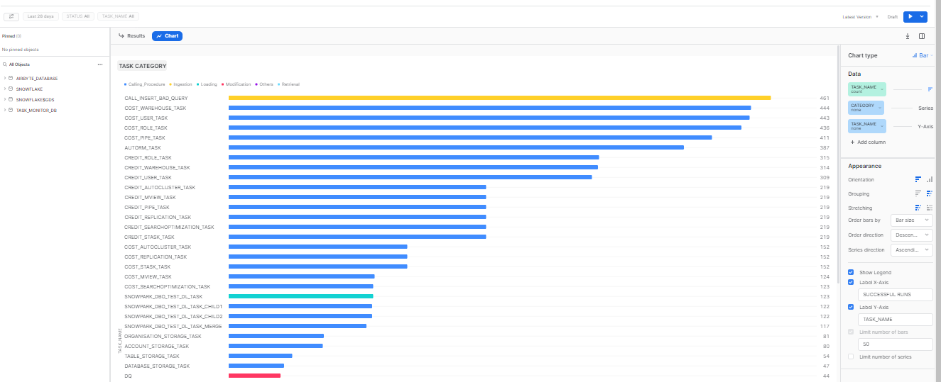

**1.12 DETAILED TASK HISTORY:**

SELECT

NAME as TASK_NAME,

date_trunc(

'second',

CONVERT_TIMEZONE('Asia/Calcutta', SCHEDULED_TIME)

) as SCHEDULED_TIME,

initcap(STATE) AS STATUS,

ERROR_MESSAGE,

CONDITION_TEXT,

RUN_ID

FROM

snowflake.account_usage.task_history

WHERE

SCHEDULED_TIME = :daterange

AND NAME = :TASK_NAME

AND STATE = :STATUS

-- AND QUERY_ID='79a679c0616ccd7527c606624700e4e4'

ORDER BY

SCHEDULED_TIME DESC;

//SELECT * FROM snowflake.account_usage.task_history;

